Nama : Ahyana Ilham W

NIM : L200170170

Kelas : D

# MODUL 7

Static Route, RIP dan IGRP

# Kegiatan 1. Topologi 1 (Static Routing)

1. Topologi.

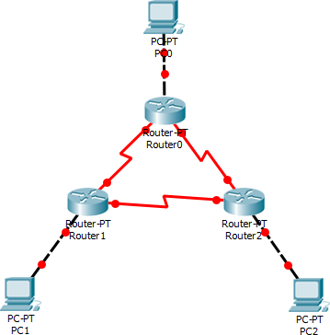

1. Memberi nama masing-masing router.

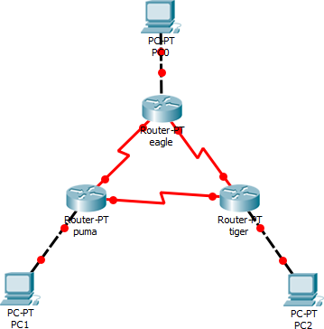

1. 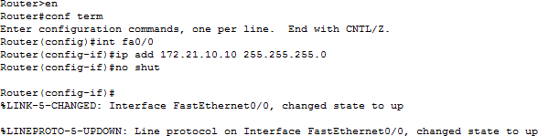Melakukan konfigurasi masing-masing interface pada tiap router. a. Eagle (ethernet 0) = 172.21.10.10/24

b. Eagle (serial 0) = 172.21.1.1/24

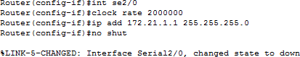

Thank you for using [www.freepdfconvert.com](http://www.freepdfconvert.com/) service!

Only two pages are converted. Please Sign Up to convert all pages. <https://www.freepdfconvert.com/membership>